A537-AM,S-Venus Figurine-Many Breasts-Solid Terra cotta-

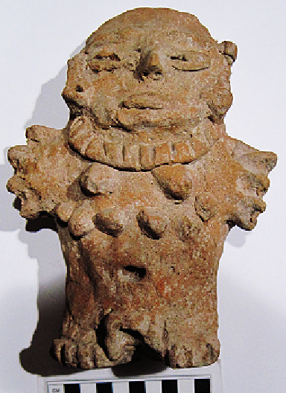 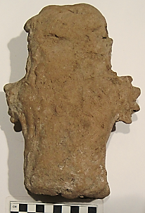

**Case no.: 9**

**Accession Number: A537**

**Formal Label:**

**Display Description:**

**LC Classification:**

**Date or Time Horizon:**

**Geographical Area:**

**Map:**

**GPS coordinates:**

**Cultural Affiliation:**

**Media:**

**Dimensions:**

**Weight:**

**Condition:**

**Provenance:**

**Discussion:**